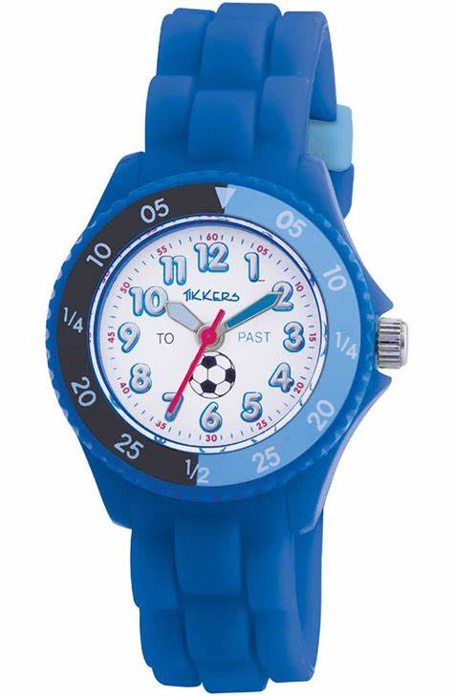**Tikkers**

Description: Tikkers is a brand that specializes in creating watches for children, designed to be fun, colorful, and educational. These watches are often made with vibrant, appealing designs, featuring characters, patterns, or themes that children enjoy. Tikkers watches typically have features that make them easy for kids to use, such as simple analog or digital displays and user-friendly interfaces.

In addition to looking stylish, Tikkers watches are also made with durability in mind, as they're intended to withstand the active lifestyle of kids. Some models even include extra features like alarms, LED lights, or water resistance, adding an extra layer of fun and functionality for young wearers.